1. Let’s see how to take value from the form element back to business logic (Component View Logic).
2. Banana in a box approach.
3. 
4. Till now, we have studied two kinds of binding 🡺 Interpolation🡺{{componentProperty}}, 2nd🡺Event Binding🡺(click)=”handler()”
5. Let’s talk about the 3rd type which is mix of these two which is called “Banana in a box” approach.
6. 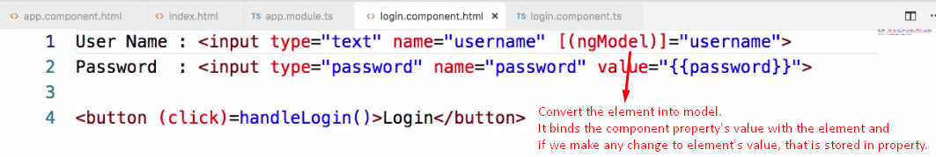
7. 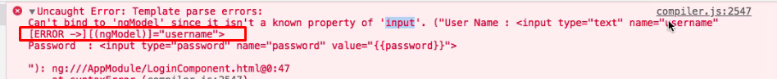
8. 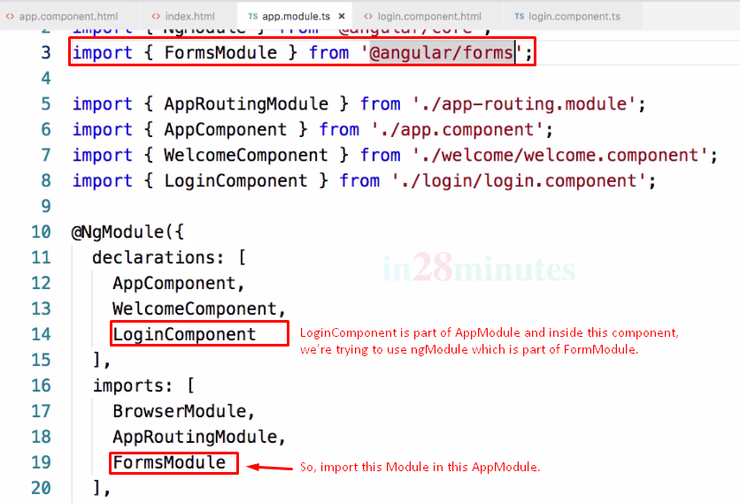
9. 